* **Objective:**

1. The objective of this project is to propose a model for Detecting multiple targets from a from a live video feed. Where we are designing the model Stationary Wavelet Transform (SWT), Principal Component Analysis (PCA), and a fusion of Convolutional Neural Networks (CNN) and Temporal Convolutional Networks (TCNs).
2. Instead of directly applying the raw video to the hybrid model designed, priority is given to extracting the SWT coefficients to provide better spectral information of each frame. PCA is applied to that spectral information to reduce the dimension of the resulting coefficients. The hybrid model we are designing will take the input from PCA and after processing them provides temporal video dynamics, spatial features, and dependencies
3. The goal is to achieve a good target detection accuracy in various land terrain and modes, and model should identify friendly, hostile and alien objects.

* **Methodology:**

1. Extract individual frame from the video feed.
2. Apply Stationary Wavelet Transform (SWT) which is used to extract meaningful features from hyperspectral data, aiding in image edge feature identification of the targets.
3. Apply Principal Component Analysis (PCA) to the SWT output for dimensionality reduction, reducing the dimensionality of large datasets while preserving most of the information.

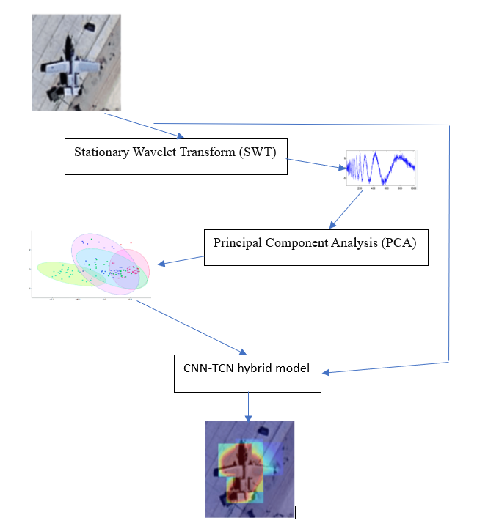

1. Apply PCA output to the algorithm designed by fusion for CNN and TCN. Which provides temporal video dynamics, spatial features, and dependencies.
2. Using the data from neural networks we can add colour spectrum to the classification map and target will be identified with it.
3. The model needs to be optimized. This may involve quantization (reducing precision of weights and activations), model pruning (removing unnecessary parameters), or other techniques to reduce model size and computational complexity.
4. Optimization Iteration: Iterate on the deployment process, optimizing further as necessary to achieve the desired balance between performance and resource usage.

* **Deliverables:**

1. Propose model integrating extracting video frames, SWT, PCA, and hybrid CNN-TCN model for multiple target detection in various situations and terrains.
2. Experimentation and validation of the model on a dataset with more than 7000 images of military aircrafts, and other targets which include friendly, hostile and alien targets.
3. Expecting of achieving a good classification accuracy and good target detection accuracy in various terrains and scenarios in real time.
4. Expecting this model to work on other modes of operations even other than combat scenario.